**CHAPTER 1**

**INTRODUCTION**

* 1. **OBJECTIVE:**

To ensure that the intended viewers are able to easily know about the importance of the pictures and objects in their own easy-to-understand language. At present the objects and pictures serve only to the select few who are conversant in English and Tamil thus depriving others the opportunity of understanding the concept of the pictures and objects as they are not well versed in these languages. It is designed to convert these descriptions into various languages by means of an app through which it can be enlightened to all those who pay a visit to the Museum.

* 1. **OVERVIEW**

Multi-Lingual Information Guidance System for Gandhi Museum is an application that serves as a handy tool for tourists who pay a visit to the museum which enable them to have a thorough knowledge of the objects displayed. The objective is to ensure that the intended viewers are able to easily know about the importance of the pictures and objects in their own easy-to-understand language. Generally these objects are displayed in twin languages as a result the tourists find it difficult to understand the importance of the pictures and objects. It is with a view to have a concise grasping of the description, an application is enabled in such a way that the objects are presented in 5 languages. This will enable them to have a better understanding of the essence of the objects

**1.3 FUNCTIONAL REQUIREMENTS:**

**1.3.1 Software Requirements:**

**Front end:** HTML,CSS,Bootstrap

**Back end**: PHP

**Operating System**: Windows

**1.3.2 Hardware Requirements:**

**Processor**: Intel core i5 processor

**RAM**: 4GB

**CHAPTER 2**

**LITERATURE REVIEW**

**2.1 LITERATURE SURVEY:**

# (i)Assisting Tourists on the Move- An Evaluation of Mobile Tourist Guides

**Authors:**

[**Christoph Grun**](https://www.researchgate.net/profile/Christoph_Grun)

# [Darmstadt University of Applied Sciences](https://www.researchgate.net/institution/Darmstadt_University_of_Applied_Sciences)Darmstadt, Germany

# Hannes Werthner Institute for Software Technology and Interactive Systems Vienna University of Technology

**Abstract:**

The penetration of high-end mobile devices equipped with GPS and enhanced with multimedia features together with decreasing mobile data prices have resulted in larger usage of mobile services. One of the application domains particularly well-suited for mobile services is tourism, not least since tourists can be assisted especially during the vacation itself. Currently, there is a proliferation of such mobile tourist guides, proposing an unmanageable number of diverse functionalities. To counteract this situation, the contribution of this paper is threefold. First, an evaluation framework is proposed, comprising both, a classification of mobile tourist services and a categorization of their delivery aspects in terms of several orthogonal dimensions. Second, on basis of this framework, four representative mobile tourist guides are evaluated, thereby

demonstrating the frameworks' applicability. Third, several lessons learned are discussed, thereby shedding light on the current state of effort in the area of mobile tourist

# (ii) Designing a Smart Museum: When Cultural Heritage Joins IoT

# Authors:

[**Angelo Chianese**](http://ieeexplore.ieee.org/search/searchresult.jsp?searchWithin=%22Authors%22:.QT.Angelo%20Chianese.QT.&newsearch=true)

Dept. of Electr. Eng. & Inf. Technol., Univ. of Naples Federico II, Naples, Italy

[**Francesco Piccialli**](http://ieeexplore.ieee.org/search/searchresult.jsp?searchWithin=%22Authors%22:.QT.Francesco%20Piccialli.QT.&newsearch=true)

Dept. of Electr. Eng. & Inf. Technol., Univ. of Naples Federico II, Naples, Italy

**Abstract:**

The adoption of the Internet of Things (IoT) paradigm constitutes the basic building block to progress towards unified ICT platforms for a variety of applications within the large framework of the smart cities. Unfortunately, designing a general architecture for IoT is still a very complex challenge, since in such system may be involved several devices, link layer technologies and services. Cultural Heritage represents a worldwide resource of inestimable value and it gains more and more importance when embedded into the digital ecosystem of a smart city. In this paper we focus specifically to design a IoT architecture that is able to support the designing of a smart museum, a static cultural space that becomes intelligent thanks to the definition of an innovative model of sensors and services. Furthermore, the paper will present and discuss a real case of study, placed in a temporary art exhibition of sculptures in the Maschio Angioino Castle, located in Naples, Italy.

# (iii) Enhancing museum exhibitions with interactive digital content

# Authors:

# [Selma Rizvic](http://ieeexplore.ieee.org/search/searchresult.jsp?searchWithin=%22Authors%22:.QT.Selma%20Rizvic.QT.&newsearch=true)

# Faculty of Electrical Engineering, Sarajevo Sarajevo, Bosnia and Herzegovina

# [Vensada Okanović](http://ieeexplore.ieee.org/search/searchresult.jsp?searchWithin=%22Authors%22:.QT.Vensada%20Okanovi%C4%87.QT.&newsearch=true)

# Faculty of Electrical Engineering, Sarajevo Sarajevo, Bosnia and Herzegovina

**Abstract:**

# Digital technologies prove to be a very efficient tool in enhancing museum exhibitions. In this paper we describe the Interactive Sarajevo City Model project. It is an application which shows a digital version of Sarajevo old town physical model which represents the appearance of the city during the Ottoman period. Instead of pointing out particular cultural heritage objects in the physical model, the curators and museum visitors can click on the corresponding info points in the application and obtain the information about those objects and their history. The paper presents the application development workflow together with some issues within the standalone implementation and user perception of such enhanced museum exhibition.

# (iv)SmARTweet: A Location-Based Smart Application for Exhibits and Museums

# Authors:

# [Angelo Chianese](http://ieeexplore.ieee.org/search/searchresult.jsp?searchWithin=%22Authors%22:.QT.Angelo%20Chianese.QT.&newsearch=true)

Dept. of Electr. Eng. & Inf. Technol., Univ. of Naples Federico II, Naples, Italy

# [Fiammetta Marulli](http://ieeexplore.ieee.org/search/searchresult.jsp?searchWithin=%22Authors%22:.QT.Fiammetta%20Marulli.QT.&newsearch=true)

Dept. of Electr. Eng. & Inf. Technol., Univ. of Naples Federico II, Naples, Italy

# [Vincenzo Moscato](http://ieeexplore.ieee.org/search/searchresult.jsp?searchWithin=%22Authors%22:.QT.Vincenzo%20Moscato.QT.&newsearch=true)

# Dept. of Electr. Eng. & Inf. Technol., Univ. of Naples Federico II, Naples, Italy

**Abstract:**

In this paper, we present "Smartweed", a Locationbased application developed within DATABENC, a high technology district for Cultural Heritage management. In particular, the project aims at exploiting several location-based services and technologies to realize a smart multimedia guide system able to detect the closest artworks to an user, make them able to "tweet" and "talk" during tourists' visit and capable of automatically telling their stories using multimedia facilities. Moreover, we have deployed and tested the installation of some sensors that, using Wi-Fi technology, allow to the users' mobile devices to detect the closest artwork in a museum environment. Once an artwork has been detected, the related identifier is retrieved and a multimedia story is delivered to user by means of proper multimedia delivery and user-profiling techniques, in order to facilitate and make more stimulating the visit. The artworks detection was performed by a localization algorithm that we designed and tested in our laboratory rooms. As case of study, we show an example of "tweeting and talking artworks" as a location-based application of a sculptures' art exhibition within the Maschio Angioino castle, in Naples - Italy.

# (v)Interexchange Museum Database via Web Service

# [L. Kovavisaruch](http://ieeexplore.ieee.org/search/searchresult.jsp?searchWithin=%22Authors%22:.QT.L.%20Kovavisaruch.QT.&newsearch=true)

# Digital Media Inf. Lab., Nat. Electron. & Comput. Technol. Center, Pathumthani, Thailand

# [V. Sornlertlamvanich](http://ieeexplore.ieee.org/search/searchresult.jsp?searchWithin=%22Authors%22:.QT.V.%20Sornlertlamvanich.QT.&newsearch=true)

# Digital Media Inf. Lab., Nat. Electron. & Comput. Technol. Center, Pathumthani, Thailand

# [P. Kamolvej](http://ieeexplore.ieee.org/search/searchresult.jsp?searchWithin=%22Authors%22:.QT.P.%20Kamolvej.QT.&newsearch=true)

Dept. of Sci., Kasetsart Univ., Bangkok, Thailand

**Abstract:**

This paper is a conceptual presentation of a standardized museum database capable of exchanging information across various museum exhibitions in different countries. The design is a result of a study conducted on the database for cultural and artistic museum collections from multiple agencies. The study proposes a standardized database containing a collection of common, required information among museums, as well as additional related information. Implementation of the conceptual database design is expected to ensure important information is not lost during data exchange, allow remote database searches from one museum to another, and enable the exchange of cultural and artistic information internationally between countries that employ the same standard.

# (vi) Development of Internet virtual butterfly museum

# Authors :

# [Wernhuar Tarng](http://ieeexplore.ieee.org/search/searchresult.jsp?searchWithin=%22Authors%22:.QT.%20Wernhuar%20Tarng.QT.&newsearch=true)

# Dept. of Math. & Sci. Educ., Nat. Hsin-Chu Teachers Coll., Taiwan

**Abstract:**

The butterfly is a valuable nature resource from the viewpoint of education and tourism. In recent years, the over-exploitation of mountainous areas and overuse of pesticide results in dramatic decrease of butterfly species and populations. This paper studies the related network and virtual reality technologies for developing a virtual butterfly museum and the objective is to provide students and the general public with a web-learning environment for studying butterfly ecology. The virtual museum exhibits several species of butterflies, including Pieridae, Papilionidae, Danaidae, Satyridae, Nymphalidae, as well as insects often seen in Taiwan. We can visit it through network at any time and from anywhere to proceed with observation and learning activities, and discuss with others on the website. Therefore, it can help people understand butterfly ecology and promote the protection of natural environments.

**CHAPTER 3**

**PROBLEM STATEMENTS**

At present the objects and pictures serve only to the select few who are conversant in English and Tamil thus depriving others the opportunity of understanding the concept of the pictures and objects as they are not well versed in these languages. The descriptions as displayed in these objects is presented in such a way that it is easily understandable to the viewers in their own languages. It is designed in various languages enabling the tourists to have a clear picture of the objects.

**CHAPTER 4**

**SYSTEM ANALYSIS**

**4.1 EXISTING SYSTEM**

* The objects as displayed in its present state does not help enlighten the essentiality of the objects as it is displayed depriving them an opportunity to know the true essence of the objects.
* Often Tourists face problems in understanding the concept in these languages.
* As a result they seek the guidance of others who mislead the information and thus they carry a wrong picture of the importance of the pictures

**4.2 PROPOSED SYSTEM:**

* The system is planned in such a way that the descriptions on display will be projected in languages which enables the tourists to have better view of the objects.
* In addition the format is also developed as text to speech mode so that is understandable to any tourists visiting the museum

**CHAPTER 5**

**SYSTEM REQUIREMENTS**

**5.1 FRONTEND REQUIREMENTS:**

**5.1.1 HTML5**

**HTML5** is amarkup language used for structuring and presenting content on the World Wide Web. It is the fifth and current version of the HTML standard.

It was published in October 2014 by the World Wide Web Consortium (W3C) to improve the language with support for the latest multimedia, while keeping it easily readable by humans and consistently understood by computers and devices such as web browsers, parsers, etc. HTML5 is intended to subsume not only HTML4, but also XHTML 1 and DOM Level 2 HTML.

HTML5 includes detailed processing models to encourage more interoperable implementations; it extends, improves and rationalizes the markup available for documents , and introduces markup and application programming interfaces (APIs) for complex web applications. For the same reasons, HTML5 is also a potential candidate for cross web applications, with features having been designed with low-powered devices such as smartphones and tablets taken into consideration.

**5.1.2 CSS**

CSS is a language for describing the presentation of Web pages including colors, layout and fonts. It allows one to adapt the presentation to different types of devices, such as large screens, small screens, or printers. CSS is independent of HTML and can be used with any XML- based markup language. The separation of HTML from CSS makes it easier to maintain sites, share style sheets across pages,

and tailor pages to different environments. This is referred to as the separation of structure (or content) from presentation.

**5.1.3 BOOTSTRAP FRAMEWORK**

**Bootstrap** is a  [free and open-source](https://en.wikipedia.org/wiki/Free_and_open-source_software) front-end [web framework](https://en.wikipedia.org/wiki/Web_framework) for designing [websites](https://en.wikipedia.org/wiki/Website) and [web applications](https://en.wikipedia.org/wiki/Web_application). It contains [HTML](https://en.wikipedia.org/wiki/HTML) and [CSS](https://en.wikipedia.org/wiki/CSS)-based design templates for [typography](https://en.wikipedia.org/wiki/Typography), forms, buttons, navigation and other interface components, as well as optional [JavaScript](https://en.wikipedia.org/wiki/JavaScript) extensions. Unlike many web frameworks, it concerns itself with [front -end development](https://en.wikipedia.org/wiki/Front-end_web_development) only.

Bootstrap is modular and consists of a series of LESS style sheets that implement the various components of the toolkit. A style sheet called bootstrap less includes the components style sheets. Developers can adapt the bootstrap file itself, selecting the components they wish to a central configuration style sheet. More profound changes are possible by the LESS declarations.

The use of LESS style sheet language allows the use of variables , functions and operator, Nested selectors , as well as so-called mixings. Since version 2.0, the configuration of Bootstrap also has a special “customize” option in the documentation .Moreover , the developer chooses on a form the desired components and adjusts, if necessary, the values of various options to their needs. The subsequently generated package already includes the pre-built CSS style sheet. As of bootstrap 4,SASS will be used for style sheets instead of LESS.

**Features:**

Bootstrap 3 supports the latest versions of the [Google Chrome](https://en.wikipedia.org/wiki/Google_Chrome), [Firefox](https://en.wikipedia.org/wiki/Firefox), [Internet Explorer](https://en.wikipedia.org/wiki/Internet_Explorer), [Opera](https://en.wikipedia.org/wiki/Opera_(web_browser)), and [Safari](https://en.wikipedia.org/wiki/Safari_(web_browser)) (except on Windows). It additionally supports back

to [IE8](https://en.wikipedia.org/wiki/Internet_Explorer_8) and the latest [Firefox](https://en.wikipedia.org/wiki/Firefox) Extended Support Release (ESR)Since 2.0, Bootstrap supports [responsive web design](https://en.wikipedia.org/wiki/Responsive_Web_Design). This means the layout of web pages adjusts dynamically, taking into account the characteristics of the device used (desktop, tablet, mobile phone).

Starting with version 3.0, Bootstrap adopted a [mobile-first design](https://en.wikipedia.org/wiki/Mobile-first_design) philosophy, emphasizing responsive design by default.

The version 4.0 alpha release added [Sass](https://en.wikipedia.org/wiki/Sass_(stylesheet_language)) and [flex box](https://en.wikipedia.org/wiki/CSS_Flex_Box_Layout) support.

**5.1.3.1 Advantages of Bootstrap**

**1.Bootstrap is compatible with the latest versions of all major browsers.** We don’t have to worry about what operating system you are currently running.

|  | **Chrome** | **Firefox** | **Safari** | **Android Browser & WebView** | **Microsoft Edge** |
| --- | --- | --- | --- | --- | --- |
| **Android** | Supported | Supported | N/A | Android v5.0+ supported | N/A |
| **iOS** | Supported | Supported | Supported | N/A | N/A |
| **Windows 10 Mobile** | N/A | N/A | N/A | N/A | Supported |

**Fig 5.1 Compatibility of Bootstrap**

**2.Easy to Use**

It is extremely an easy and speedy procedure to begin with Bootstrap. Bootstrap is very adaptable too. You can utilize Bootstrap along with CSS, or LESS, or also with Sass

**3. Responsiveness**

Every year mobile devices persist to grow hugely popular, and the requirement to have a responsive website has become compulsory and important too. As the fluid grid layout amends vigorously to the appropriate screen resolution, thus crafting a mobile-ready site is a smooth and easy task along with Bootstrap. With the use of ready-made classes of Bootstrap, you can recognize the number of spots in the grid system that you would like each column to engage in. Then only you can identify at whichever point you would like your columns to load in horizontal position, instead of vertically to exhibit accurately on mobile appliances.



**Fig 5.2 Different devices**

**4. The Speed of the Development**

One of the main benefits of utilizing Bootstrap happens to be the speed of the development. While driving out a new, fresh website or application swiftly, you should certainly reflect upon utilizing Bootstrap. Instead of coding from scrape,

Bootstrap lets you to use ready-made coding blocks in order to assist you in setting up. You can blend that along with CSS-Less functionality and cross-browser compatibility that can give way to saving of ample hours of coding. You can even buy ready-made Bootstrap themes and alter them to fit your requirements, for gaining the quickest potential route.

**5. Customizable Bootstrap**

The Bootstrap can be customized as per the designs of your project. The web developers can make a choice to select the aspects which are required which can be simply complete by utilizing Bootstrap customize page. You just have to tick off all the aspects that you do not require, such as- Common CSS: typography, code, grid system, tables, buttons, forms, print media styles; Components: input groups, button groups, pager, labels, navs, navbar, badges, pagination; JavaScript components: dropdowns, popovers, modals, tooltips, carousels; Utilities: Responsive utilities, basic utilities. Thus your custom version of Bootstrap is all set for download process.

**6. Consistency**

Few Twitter employees firstly expanded Bootstrap as a framework for boosting the consistency across interior tools. But later the Co-founder Mark Otto after understanding the actual potential released in August 2011 the first open-source version of Bootstrap. He even portrayed how the Bootstrap was enlarged with the use of one core concept- pairing of designers along with developers. Thus Bootstrap became popular on Twitter.

**7. Support**

As Bootstrap holds a big support community, you can be provided with help whenever there comes any problem. The creators always keep the Bootstrap updated. Presently Bootstrap is hosted, expanded, and preserved on the GitHub along with more than 9,000 commits, as well as more than 500 contributors.

**8. Packaged JavaScript Components**

Bootstrap approaches with a pack of JavaScript components for including the functionality that crafts it in simple way for operating things, such as tooltips, modal windows, alerts, etc. You can even leave out the writing scripts completely.

**9. Simple Integration**

Bootstrap can be simply integrated along with distinct other platforms and frameworks, on existing sites and new ones too. You can also utilize particular elements of Bootstrap along with your current CSS.

**10. Grid**

Bootstrap has the capability to utilize a 12-column grid that is responsive. It also upholds offset and nested elements. The grid can be maintained in a responsive mode, or you can simply modify it to a secured layout.

**5.2BACKEND REQUIREMETS**

**5.2.1 XAMPP Server**

XAMPP stands for Cross-Platform(X), Apache(A), MySql(M), PHP(P) and Perl(P). It is a simple, lightweight Apache distribution that makes it extremely easy for developers to create a local web server for testing purposes. Everything you

need to set up a web server –server application(Apache),database(MySQL), and scripting language(PHP)- is included in a simple extractable file. XAMPP is also cross-platfrom, which means it works equally well on Linux, Mac, Windows.Since most actual web server deployments use the same components as XAMPP, it makes transitioning from a local test server to a live server is extremely easy as well

XAMPP has four primary components. These are:

**1.Apache:**Apache is the actual web server application that processes and delivers web content to a computer. Apache is the most popular web server online, powering nearly 54% of all websites.

**2.MySQL:**Every web application,however simple or complicated,requires a database for storing collected data.MySQL,which is open source,is the world’s most popular database management system.It powers everything from hobbyist websites to professional platform like WordPress.

**3.PHP:**PHP stands for Hypertext Preprocessor.It is a server-side scripting language that powers some of the most popular websites in the world,includingWordPress and Facebook.It is open source,relatively easy to learn,and works perfectly with MySQL,making it a popular choice for web developers.

**4.Perl:**Perl is a high-level,dynamic programming language used extensively in network programming,systemadmin,etc.Although less popular for web development purposes,Perl has a lot of niche applications.

Different versions of XAMPP may have additional such as phpMyAdmin,OpenSSL,etc.to create full-fledged web servers.

**5.2.1.1 Installing XAMPP**

**Step 1:**In your web browser, go to

<https://www.apachefriends.org/index.html>

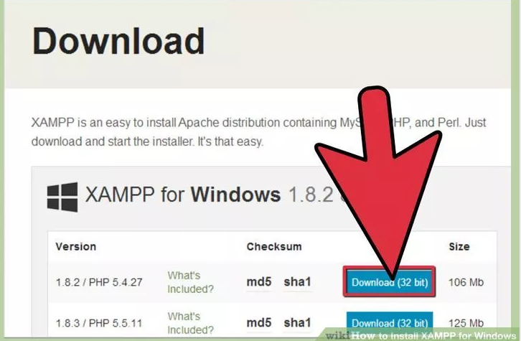

**Fig 5.3 XAMPP Software Download**

**Step 2:**Click on the download link for XAMPP.

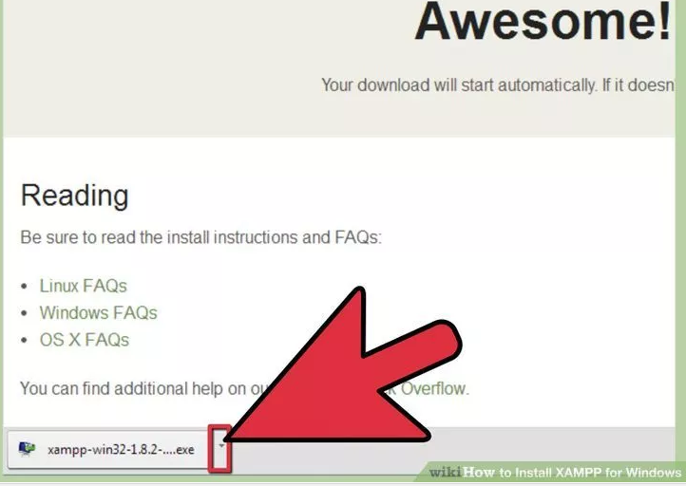

**Fig 5.4 Opening XAMPP**

**Step 3:**Open CD or DVD drive from My Computer**.** Install the program, and click on "Run."

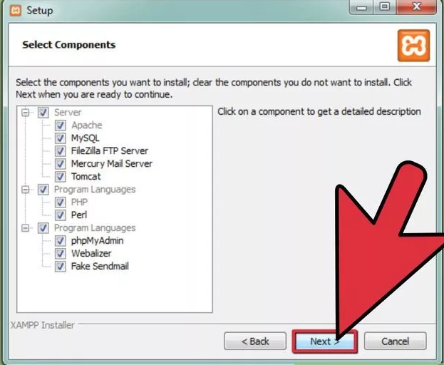

**Fig 5.5 Installation Components**

**Step 4:** A command will open and offer an initial installation prompt. Accept the default settings. To simplify installation, just hit ENTER when prompted on the command line.

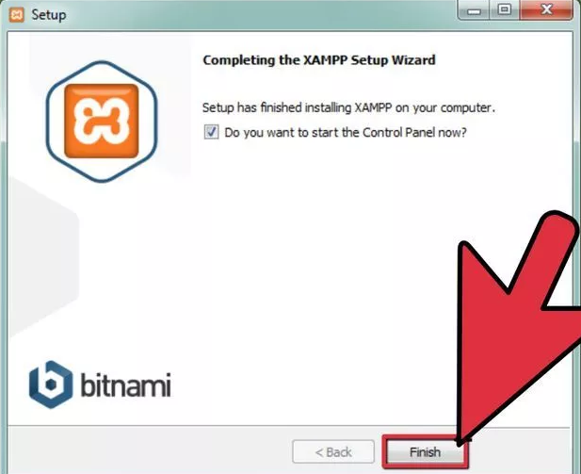

**Fig 5.6 Installation Completion**

**Step 5:**When your installation is complete, exit the command window by typing x on the command line.

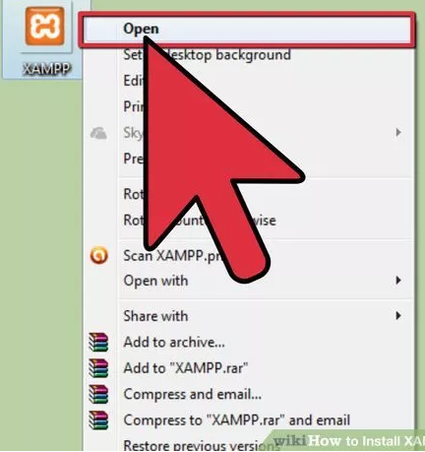

**Fig 5.7 Finishing XAMPP**

**5.2.1.2 Understanding XAMPP Control Panel**

The XAMPP control panel gives you complete control over all installed XAMPP components. You can use the CP to start/stop different modules,launch the Unix shell,open Windows explorer and see all operations running in the background.

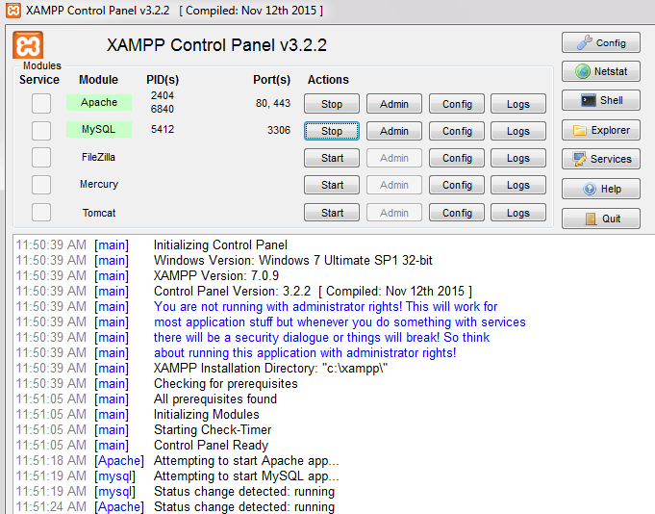

**Fig 5.7 XAMPP Control Panel**

**5.2.1.3 Testing XAMPP Installation**

Follow these steps to test XAMPP installation by launching the Apache web server ad creating a simple PHP file.

**Step 1:**In the XAMPP control panel,click on ‘Start’ under ‘Actions’for the Apache module.This instructs XAMPP to start the Apache webserver.

**Step 2:**Open your web browser and type in:http://localhost or 127.0.0.1.

**Step 3:**Select your language from the splash screen.

**Step 4:**You should see the following screen.This means you’ve successfully installed XAMPP on your computer.

**Step 5:**We will now test whether XAMPP has installed PHP successfully.To do this,fire up Notepad ad type the following into a new document:

<?php

Echo 'Hello world';

?>

Save this file as ‘test.php’ in c:\xampp\htdocs\(or whether directory you installed XAMPP in).

**Step 6:** Navigate to localhost/test.php.You should see the “Hello World”

Message.

**5.2.2PhpMyAdmin**

phpMyAdminisa free software tool written in [**PHP**](https://php.net/), intended to handle the administration of [**MySQL**](https://www.mysql.com/) over the Web. phpMyAdmin supports a wide range of operations on MySQL and MariaDB. Frequently used operations (managing databases, tables, columns, relations, indexes, users, permissions, etc) can beperformed via the user interface, while you still have the ability to directly execute any SQL statement.phpMyAdmin comes with a wide range of [documentation](https://www.phpmyadmin.net/docs/) and users are welcome to update [our wiki pages](https://github.com/phpmyadmin/phpmyadmin/wiki) to share ideas and howto use for various operations. The [phpMyAdmin team](https://www.phpmyadmin.net/team/) will try to help you if you face any problem; you can use a [variety of support channels](https://www.phpmyadmin.net/support/) to get help.

phpMyAdmin is also very deeply documented in a book written by one of the developers – [Mastering phpMyAdmin for Effective MySQL Management](https://link.packtpub.com/XJdqZr).

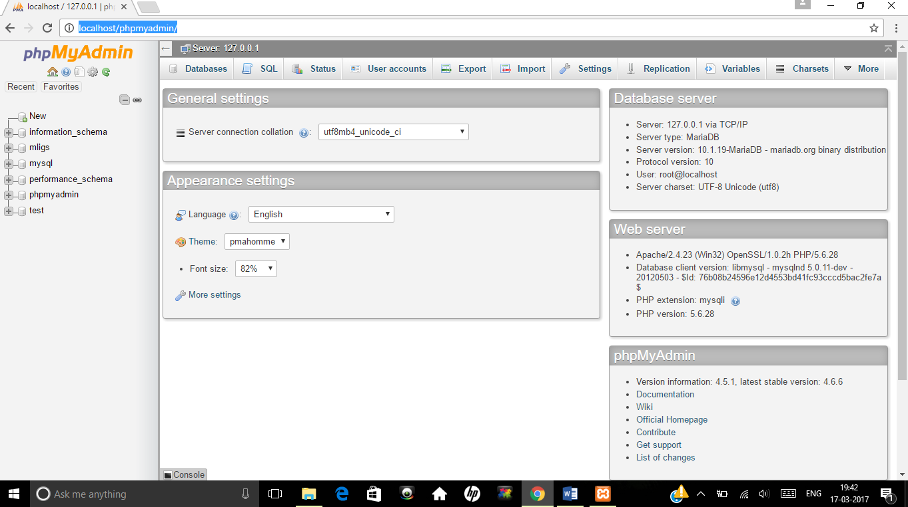

**Fig 5.8 MyAdmin table**

**CHAPTER 6**

**ARCHITECTURE OF THE PROJECT**

The architecture of the proposed ERP for**“Multi-Lingual Information Guidance System For Gandhi Museum, Madurai” is** the interface with the viewers and visual communication of the picture.The home page in figure shows the main access.

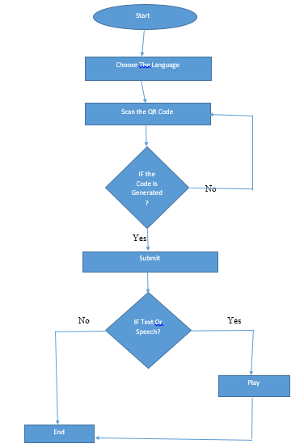

**Fig 6.1 Flow Diagram**

**6.1 SYSTEM ARCHITECTURE:**

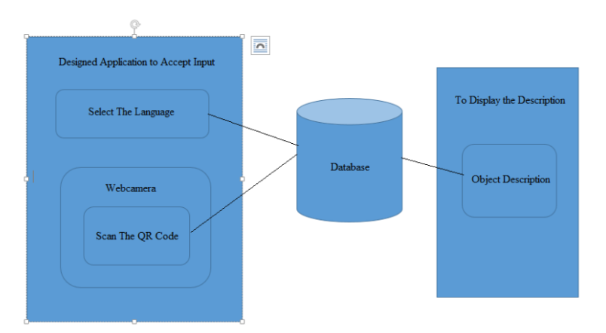

**Fig 6.2 System Architecture**

**6.2 MODULE DESCRIPTION:**

The user is required to select the language and scan the QR code so that the system is planned in such a way that the descriptions on display will be projected in languages which enables the tourists to have better view of the objects. In addition the format is also developed as text to speech mode so that is understandable to any tourists visiting the museum.

**CHAPTER 7**

**IMPLEMENTATION**

**7.1 CODING**

Test.html

<!DOCTYPE html>

<html>

<head>

<title>HTML Frames</title>

</head>

<frameset cols="50%,50%">

<frame name="left" src="\Project\main.html" />

<frame name="center" src="\Project\index1.html" />

<noframes>

<body>

</body>

</noframes>

</frameset>

</html>

**Main.html**

<!DOCTYPE html PUBLIC "-//W3C//DTD XHTML 1.0 Strict//EN" "http://www.w3.org/TR/xhtml1/DTD/xhtml1-strict.dtd">

<html xmlns="http://www.w3.org/1999/xhtml">

<head>

<meta http-equiv="Content-Type" content="text/html; charset=UTF-8" />

<title></title>

<meta name="keywords" content="" />

<meta name="description" content="" />

<link href="http://fonts.googleapis.com/css?family=Source+Sans+Pro:200,300,400,600,700,900" rel="stylesheet" />

<script src='https://code.responsivevoice.org/responsivevoice.js'></script>

<link href="bz.css" rel="stylesheet" type="text/css" media="all" />

</head>

<body>

<div id="header-wrapper">

<div id="logo">

<h1><a href="#">MULTI-LINGUAL INFORMATION GUIDANCE SYSTEM FOR GANDHI MUSEUM</a></h1>

</div>

<div id="wrapper1">

<div id="welcome" class="container">

<div class="title">

<h2 style="text-align: center;">Choose your language.</h2>

</div>

<div id="language">

<form action="product.php" method="post">

<input type="radio" name="language" value="english"><p> English</p></font></h6><br>

<input type="radio" name="language" value="french"><p> French</p><br>

<input type="radio" name="language" value="german"><p> German</p><br>

<input type="radio" name="language" value="spanish"><p> Spanish</p><br>

<input type="radio" name="language" value="hindi"><p> Hindi</p><br>

<input type="radio" name="language" value="telugu"><p> Telugu</p><br>

<input type="radio" name="language" value="tamil"><p> Tamil</p><br>

<center><label>The Qr code</label></center>

<center><input type="text" name="qr" id="qr"/></center>

<div id="sub">

<input type="submit" value="SUBMIT" Value="Click"/>

</div>

</form>

</div>

</div>

</body>

</html>

**Bz.css**

html, body

{

height: 100%;

}

@font-face {

font-family: 'Bamini Tamil';

src: url('');

}

.p{

font-family: Bamini Tamil, Helvetica, sans-serif;

}

</style>

body

{

margin: 0px;

padding: 0px;

background: #333333;

/*font-family: 'Source Sans Pro', sans-serif*/;

font-size: 12pt;

font-weight: 400;

color: #000000;

}

h1, h2, h3

{

margin: 0;

padding: 0;

}

p

{

line-height: 180%;

}

a:hover

{

text-decoration: none;

}

/*********************************************************************************/

/* Language */

/*********************************************************************************/

#language input[type=submit] {

margin-top: 2em;

padding: 1em 2em 1em 2em;

background: #000000;

border-radius: 50px;

letter-spacing: 0.10em;

line-height: 1.8em;

font-weight: 400;

text-align:center;

font-size: 1.2em;

color: #FFF;

}

#language input[type=radio] {

margin-top: 5px;

margin-left: 250px;

}

#language p{

display: inline;

color: #000000;

}

#sub {

margin-left: 400px;

}

/*********************************************************************************/

/* Heading Titles */

/*********************************************************************************/

.title

{

margin-bottom: 3em;

}

.title h2

{

font-size: 2.8em;

color: rgba(255,255,255,0.9);

}

/*********************************************************************************/

/* Header */

/*********************************************************************************/

#header-wrapper

{

overflow: hidden;

background: #000000;

}

/*********************************************************************************/

/* Logo */

/*********************************************************************************/

#logo

{

padding: 10em 0em;

text-align: center;

}

#logo a

{

text-decoration: none;

color: #FFF;

font-size: 100;

}

/*********************************************************************************/

/* Wrapper */

/*********************************************************************************/

#wrapper1

{

background: #EDEDED;

}

/*********************************************************************************/

/* Welcome */

/*********************************************************************************/

#welcome

{

overflow: hidden;

padding: 8em 0em;

color: rgba(0,0,0,0.5);

}

#welcome .title

{

}

#welcome .title h2

{

color: rgba(0,0,0,0.8);

}

**Index1.html**

<!DOCTYPE html>

<!--[if lt IE 7]><html class="no-js lt-ie9 lt-ie8 lt-ie7"><![endif]-->

<!--[if IE 7]><html class="no-js lt-ie9 lt-ie8"><![endif]-->

<!--[if IE 8]><html class="no-js lt-ie9"><![endif]-->

<!--[if gt IE 8]><!--><html class="no-js"><!--<![endif]-->

<head>

<meta charset="utf-8">

<meta http-equiv="X-UA-Compatible" content="IE=edge">

<title>Basic QR-code reader example</title>

<meta name="description" content="">

<meta name="viewport" content="width=device-width, initial-scale=1">

<link rel="stylesheet" href="css/reset.css">

<link rel="stylesheet" href="css/styles.css">

<script src="js/jquery.min.js"></script>

<script src="js/photobooth.js"></script>

<script type="text/javascript" src="js/qr/grid.js"></script>

<script type="text/javascript" src="js/qr/version.js"></script>

<script type="text/javascript" src="js/qr/detector.js"></script>

<script type="text/javascript" src="js/qr/formatinf.js"></script>

<script type="text/javascript" src="js/qr/errorlevel.js"></script>

<script type="text/javascript" src="js/qr/bitmat.js"></script>

<script type="text/javascript" src="js/qr/datablock.js"></script>

<script type="text/javascript" src="js/qr/bmparser.js"></script>

<script type="text/javascript" src="js/qr/datamask.js"></script>

<script type="text/javascript" src="js/qr/rsdecoder.js"></script>

<script type="text/javascript" src="js/qr/gf256poly.js"></script>

<script type="text/javascript" src="js/qr/gf256.js"></script>

<script type="text/javascript" src="js/qr/decoder.js"></script>

<script type="text/javascript" src="js/qr/qrcode.js"></script>

<script type="text/javascript" src="js/qr/findpat.js"></script>

<script type="text/javascript" src="js/qr/alignpat.js"></script>

<script type="text/javascript" src="js/qr/databr.js"></script>1

<script src="js/effects.js"></script>

<script>

function handler() {

var textbox = parent.left.document.getElementById('qr');

textbox.value = document.getElementById('ran').innerHTML;

}

</script>

</head>

<body>

<div class="pageWrapper">

<div class="boxWrapper">

<div id="example"></div>

</div>

<div class="button">

<a id="button" onclick="handler()" >Scan QR code</a>

</div>

<div class="boxWrapper auto">

<div id="hiddenImg"></div>

<div id="qrContent"><p id="ran" >Result will be here.</p></div>

</div>

</div>

</body>

</html>

**Product.php**

<!DOCTYPE html PUBLIC "-//W3C//DTD XHTML 1.0 Strict//EN" "http://www.w3.org/TR/xhtml1/DTD/xhtml1-strict.dtd">

<html xmlns="http://www.w3.org/1999/xhtml">

<head>

<meta http-equiv="Content-Type" content="text/html; charset=UTF-8" />

<title></title>

<meta name="keywords" content="" />

<meta name="description" content="" />

<link href="http://fonts.googleapis.com/css?family=Source+Sans+Pro:200,300,400,600,700,900" rel="stylesheet" />

<link href="bz.css" rel="stylesheet" type="text/css" media="all" />

</head>

<body>

<div id="header-wrapper">

<div id="logo">

<h1><a href="#">MULTI-LINGUAL INFORMATION GUIDANCE SYSTEM FOR GANDHI MUSEUM</a></h1>

</div>

<div id="wrapper1">

<div id="welcome" class="container">

<div class="title">

<h2 style="text-align: center;"></h2>

</div>

<div align="center">

<form>

<br><br><br>

<label>Description</label>

<br><br>

</form>

</div>

</html>

<?php

$servername = "localhost";

$username = "root";

$password = "";

$dbname = "mligs";

// Create connection

$conn = new mysqli($servername, $username, $password, $dbname);

// Check connection

$conn->query("SET NAMES 'utf8'");

if ($conn->connect_error) {

die("Connection failed: " . $conn->connect_error);

}

if(isset($_POST['language']))

{

$value1=$_POST['language'];

}

$value2=$_POST["qr"];

echo "$value2";

$sql = "SELECT de FROM $value1 WHERE ID='$value2'";

$result = $conn->query($sql);

if ($result->num_rows> 0) {

// output data of each row

while($row = $result->fetch_assoc()) {

echo "<div align='center'><textarea rows='20' cols='50' id='text'> " .$row["de"]."</textarea></div>";

}

} else {

echo "0 results";

}

?>

<script src='https://code.responsivevoice.org/responsivevoice.js'></script>

<center><button id="demo">Play</button></center>

<script>

document.getElementById("demo").onclick = responsiveVoice.speak(document.getElementById("text").value);

</script>

**CHAPTER 8**

**TESTING AND DEPLOYMENT**

**8.1 UNIT TESTING**

Unit testing is a software development process in which the smallest testable parts of an application, called units, are individually and independently scrutinized for proper operation. Unit testing can be done manually but is often automated. Each modules are configured and is tested for proper working.

**8.2 INTEGRATION TESTING**

Integrationtesting is the phase in software testing in which individual software modules are combined and tested as a group. It occurs after unit testing. It checks whether the modules are working properly after making connections with one another.

**8.3 SYSTEM TESTING**

System testing of software or hardware is testing conducted on a complete, integrated system to evaluate the system's compliance with its specified requirements. We verify whether the entire system executes the required feature.

**8.4 PERFORMANCE TESTING**

Performance testing, a non-functional testing technique performed to determine the system parameters in terms of responsiveness and stability under various workload. Performance testing measures the quality attributes of the system, such as scalability, reliability and resource usage.

**8.5 DEPLOYMENT AND MAINTENANCE**

In deployment stage, we release or distribute our work in a production environment to test the proper functionality and to maintain and enhance the system design to cope with newly discovered problems.

**8.6EXPERIMENTAL RESULT**

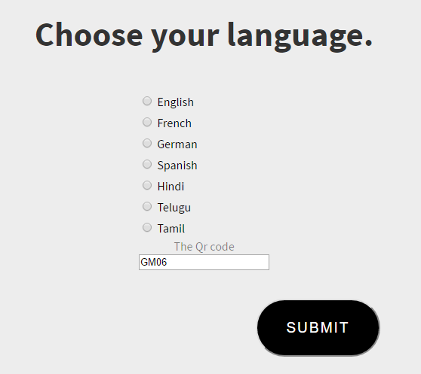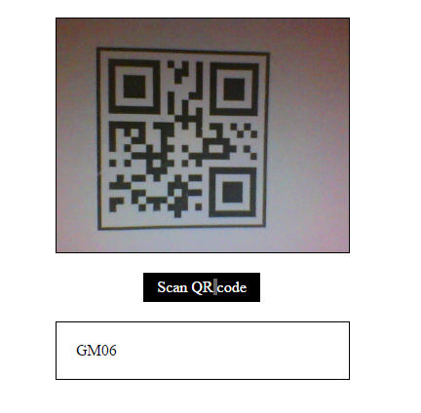

**Fig 8.1 Home Screen**

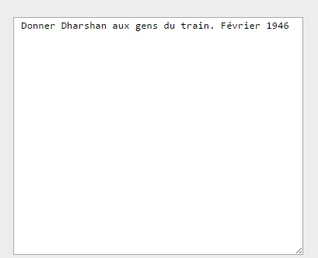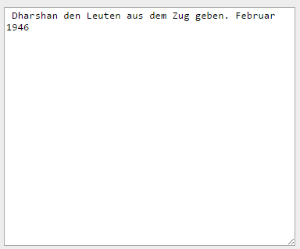

**Fig 8.2 Result 1**

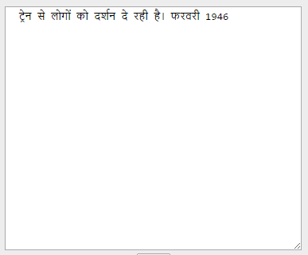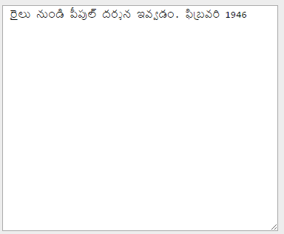

**Fig 8.3 : Result 2**

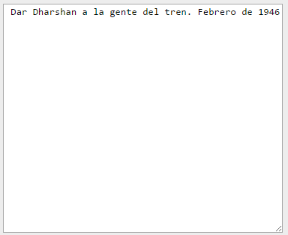

**Fig 8.4 Result 3**

**8.7 Performance Analysis**

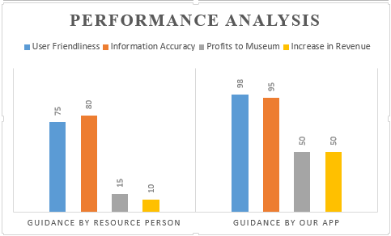

**Fig 8.5 : Performance Graph**

**Guidance By Resource Person :**

|  |
| --- |
| **User Friendliness:**  The guide may or may not be able to understand the tourists language.  **Information Accuracy:**  The possibility of receiving false information is high***.***  **Increase in Revenue:**  This does not provide any possible way to increase the revenue.  **Guidance By Our WebApp**  **User Friendliness:**  Here the user specifies their preferred language  **Information Accuracy:**  Accurate information is provided to the viewers.  **Increase in Revenue:**  Because of the use of technically advanced user-friendly system tourist may show greater interest to visit the place which in turn increases the revenue.  **Conclusion :**  Enhancement of tourism revenue thereby contributing to the growth of the museum. Inflow of tourists will increase substantially. In addition expansion of other business contributing to the overall growth of the city. This will immensely help in enhancing the revenue potential of the Museum, thus putting a cascading effect on the growth of the place. |
|  |
|  |

**CHAPTER 9**

**APPENDICES**

**When the system starts initialization.**



The user must choose the language of his own choice. A QR Code will be placed near the object. The user is required to scan the QR code which enables them to view the objects in their own language. If the user wants it can be changed to text tospeech.

Enhancement of tourism revenue thereby contributing to the growth of the museum. Inflow of tourists will increase substantially. In addition expansion of other business contributing to the overall growth of the city. Gaining an insight about the freedom movement

Guides often mislead the tourists thereby carrying a wrong information of the objects. This will affect the tourism potential of the place.

**REFERENCE:**

* **https://github.com/Kephson/html5qrcodereader**
* **http://gandhimuseum.org/site/gandian-institute/national/gandhi-museum-madhurai**
* **https://www.w3schools.com/php/php_mysql_intro.asp**
* **https://github.com/sarxos/webcam-capture/tree/master/webcam-capture-examples/webcam-capture-qrcode/src/main/java/com/github/sarxos/webcam**